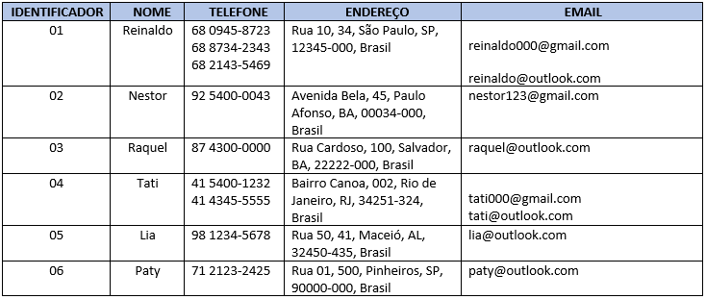

| 01 | reinaldo | 68 0945-8723 | rua 10, 34, São paulo, SP, 12345-000, Brasil | reinaldo000@gmail.com |
| --- | --- | --- | --- | --- |
| 01 | reinaldo | 68 8734-2343 | rua 10, 34, São paulo, SP, 12345-000, Brasil | reinaldo@gmail.com |
| 01 | reinaldo | 68 2143-5469 | rua 10, 34, São paulo, SP, 12345-000, Brasil | reinaldo@gmail.com |
| 02 | nestor | 92 5400-0043 | avenida bela, 45, paulo afonso, BA, 0034-000, Brasil | nestor123@gmail.com |
| 03 | raquel | 87 4300-0000 | rua cardoso, 100, salvador, ba, 2222-00, brasil | raquel@outlook.com |
| 04 | tati | 41 5400-1232 | bairro canoa, 002, rio de janeiro, rj, 34251-324, Brasil | tati0000@gmail.com |
| 04 | tati | 41 4345-5555 | bairro canoa, 002, rio de janeiro, rj, 34251-324, Brasil | tati@outlook.com |
| 05 | lia | 98 1234-5678 | rua 50, 41, macéio, AL, 32450-435, Brasil | lia@outlook.com |
| 06 | paty | 71 2123-2425 | rua 01, 500, pinheiros, SP, 90000-000, Brasil | paty@outlook.com |